
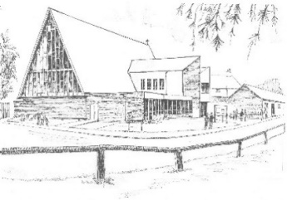
URC Broxbourne
Mill Lane EN10 7BQ
May CRAFT & PLANT Market
Monday 4th May 1.30pm – 4.30pm
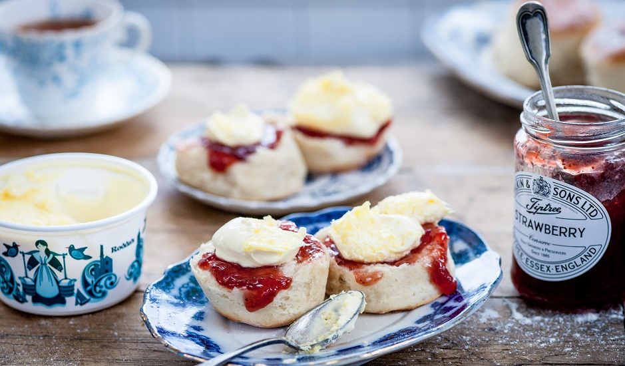


Plants
Crafts Cream Teas
Or come & sell – for tables ring 07707 180296
Charity number 1152449

