November 2025

Minister: Revd. Mark Robinson 07510782031 revdmarkr@gmail.com
Treasurer: Amanda Harwood
Pastorate Administrator: Stepanka Moysey Mobile 07362592580 urcnlvg@gmail.com
Guest editor: Dorothy Blatcher

Letter from Mark
Dear Friends,

November can feel solemn. Across our communities and in towns and cities, poppies bloom on coats and wreaths are laced on stone. There’s a hush before the bugle sounds, a pause filled with remembrance and emotion. We remember.

Yet remembrance in faith is never only Looking backward. It is the heartbeat of relationship, the way God stays with us across time. Scripture speaks again and again of a God who remembers:
God remembers Noah and the flood begins to recede.
God remembers Sarah and new life begins.
God remembers the cry of an enslaved people and freedom rises through the sea.

To remember, in the way God remembers, is to keep love alive. It is to hold a promise until it becomes real. God’s remembrance brings life, mercy, and restoration. Every act of remembrance in our worship, our silence, or our prayer joins that divine rhythm.

And yet, we give thanks for another kind of memory; the gracious forgetting that belongs to God alone. The psalmist sings of sins removed as far as east from west, of mercy that does not record the old ledger of wrongs. God’s forgetting clears space for new beginnings. It opens the way for peace to grow again.

Remembrance Day invites both thankful memory and holy forgetting. We honour those whose courage and loss have shaped the world we inherit. We hold before God the pain that lingers in lands still torn by conflict. And we lean into the hope that grows when grace remembers love and releases shame.

So as you wear your poppy, light your candle, or stand in silence this month, let that silence speak both ways: a remembering that heals and a forgetting that frees.
May the God who remembers in mercy and forgets in love breathe peace into every restless heart.

Grace and peace, Mark
Prayer Prompts – November

Week 1 – God Remembers in Mercy
Scripture: God remembered Noah… and the waters receded. (Genesis 8:1)
Prayer: God of mercy, thank You for remembering creation with love and holding us through every storm.
Action: Recall a time when God’s care carried you through difficulty. Give thanks aloud or in silence.

Week 2 – God Remembers Promise
Scripture: Now the Lord was gracious to Sarah as he had said, and the Lord did for Sarah what he had promised. (Genesis 21:1)
God remembered Sarah and did as God had promised.
Prayer: Faithful God, renew Your promises in us. Let hope rise again in our hearts and in our world.
Action: Write one hope for the future of our church or community and place it somewhere you will see daily.

Week 3 – God Forgets in Grace
Scripture: I will remember their wrongdoing no more. (Jeremiah 31:34)
Prayer: God of grace, thank You for letting go of what harms and freeing us to begin again.
Action: Think of one burden or regret. Offer it in prayer, then release it; maybe by tearing a small piece of paper as a sign of release.

Week 4 – God’s Remembering Brings Peace
Scripture: The steadfast love of God never ceases. (Lamentations 3:22)
Prayer: God of peace, remember our world with compassion. Let Your steadfast love mend what war and hatred break.
Action: Light a candle this week for all who long for peace; in homes, in nations, in hearts.

A Measure of Breath – My New Book, Now Published
Some of you may remember I mentioned a book I had been working on for quite a while. I’m delighted to share that A Measure of Breath has now been published. It’s been a long journey, shaped by faith, endurance, and reflection.
It’s a contemplative novel that explores faith, silence, and healing, and it will soon be available through major booksellers.
Grace and breath,
Mark

Our Harvest Festival Sunday 28 September
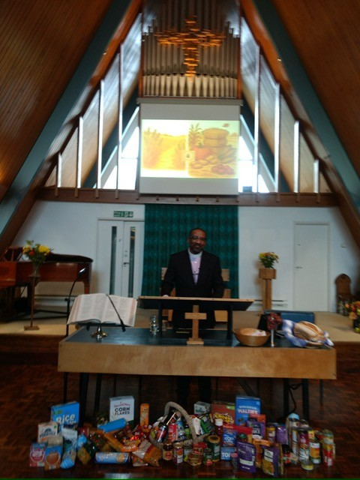 | 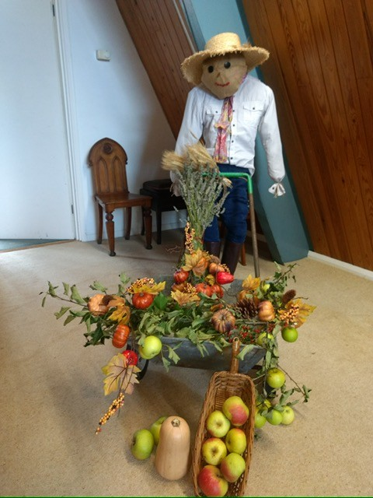
This just missed our October magazine. Thanks to everyone – for bringing food for the food bank, to Mark for leading our fruitful service, to Diane and Helen for the glorious harvest decorations, including a jolly farmer and wheelbarrow, to Gordon for packing our gifts and taking them to the food bank and Diane for the organisation and delivery of beautiful flowers to appreciative members of our fellowship. Pictures by Amanda. Please remember our food bank every week.
November Services
2 Nov  10.30 |  | David Ronco
9 Nov 10.15 | Remembrance Sunday  10.15 service. 10.45 parade to war memorial.  There will be a service in our church for those not going to the war memorial.  The 1st Broxbourne Guides are joining us. | Mark Robinson  Rosemary Woodall
16 Nov 10.30 | Communion -Natasha | Anne Pulford
23 Nov  10.30 | Church meeting following the service | Mark Robinson
30 Nov  10.30 | First Sunday in Advent  Day after Christmas market. Pack away after service. | John Danso
7 Dec  10.30 | Toy service – please bring new toys  Communion – Rosemary | John Ellis

A big thank you for our refurbished and transformed external notice boards
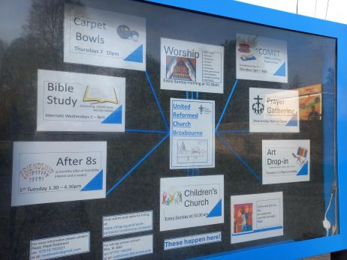
Many thanks to Ian Woodall for transforming the noticeboards – they look amazing – and to Rosemary Woodall for the attractive and detailed content. They (that is the noticeboards!) are smart, inviting, informative and welcoming. Well done! Take a look and admire.
Christmas Craft Market Saturday 29 November 10.30-2.00
Please let me know if you can help in any way, setting up, running a stall, packing away, standing in while a stall holder grabs a break etc. Set up from 3.30 on Friday 28th – all offers of help welcome.
The craft stalls are now fully booked, thanks to Mary Bite.
There will be many craft stalls, light lunches, refreshments and favourite church stalls. There will not be china and glass or bric a brac.

We need:
Home baking and preserves, labelled with ingredients for Diane’s stall
New items for gifts
New or as new toys (Toy service is on 7 December)
Please advertise and encourage your family, friends and neighbours and to come along. Posters and flyers are available for distribution. Dorothy Blatcher

Carols by Candlelight, Sunday 14 December
Last year our small singing group sang at the Carols by Candlelight Service. We want to create some more harmony as we head for the culmination of our theme of Harmony for 2025. We are gathering a group to sing an item or two at our Carols by Candlelight service. Our choices will not be too ambitious or too serious but will be enjoyable! We would love a few more to join us. We intend to have one practice for about an hour after the service on the morning of Sunday 7th December, hopefully another practice sometime during the following week, and then a final practice before the actual service. We would give you the music in advance.
Do you enjoy singing! Is this you? Hope so. If so, please speak to
Rosemary –or Dorothy B.
Would you like to be our kitchen steward?
While the cleaner keeps the floors and worktops clean, we still need someone to replenish supplies, check inside cupboards and clean appliances. Speak to Diane if you can help.
A Summer ‘Harmony Project’ Jill Nugent
Do look at the 20 ‘pages' which are now on display in the lounge.
Jill’s next art drop is on Tuesday 11th November 2-3.30 in the lounge.

CHURCH ACTIVITIES FOR YOUR DIARY
COMET Mondays 2-4pm Come along if you enjoy togetherness - meeting friends over a cuppa in the church hall, having a chat and possibly a game of Rummikub.
SHORT MAT BOWLS 7.30 Every Thursday evening in the church hall. Please speak to Alan Earl if you would like to join.
AFTER EIGHTS A programme of interesting talks in our church hall on the first Tuesday of the month 2-4pm. The next talk is on Tuesday 4th November
PRAYER GATHERING every Wednesday at 8pm via Zoom for approximately 45 minutes. All are welcome to come and pray silently or aloud, or to be still and enjoy an oasis of peace - please contact Rosemary Woodall for further information.
CONVERSATIONAL BIBLE STUDY and refreshments in the Oasis 2pm Wednesdays 12 and 26 November.

November Diary, including meetings in our hall
Tues 4th Elders’ meeting, 9:30am at the Manse
Tues 4th 2pm After Eights ‘Guilty or not guilty’
Sunday 9th 10.15 am Remembrance service. Parade at 10.45.
Tuesday 11th Jill’s art drop in in the Lounge 2-3.30
Wednesday 12th 2-4 Conversational Bible Study in the Oasis with Laurence Wednesday 12th 6.30 pm Amalgamation meeting with David Skipp
Saturday 15th November LAG Elders’ Day 10.30am to 4 am
Sunday 23rd Church Meeting following the service
Tuesday 25th 7 pm Joint Elders meeting in the church lounge
Tuesday 25th 8pm SE Herts RSPB Wildlife Photographer Alison Mees presents: A journey through Rajastan and its wildlife’. All welcome.
Wednesday 26th Conversational Bible Study with Laurence
Saturday 28th 10-2pm Our Christmas Craft market
Saturday 28th 4.30pm Hoddesdon Music Club Margaret Fingerhut – piano – repertoire including Chopin. Craft Market stalls open during the interval.
Tuesday 18th 7.50pm Friends of Lowewood Museum: ‘James Nicolson VC’
Churches Together in Hoddesdon. Broxbourne and Wormley – Homeless Support. Churches Together have agreed to continue with the provision of starter packs and mobile phones to Broxbourne Council to give to rough sleepers who need them. Starter packs comprise bedding, bathroom and kitchen items to help the homeless when they move into the largely empty accommodation provided by the Council. It was agreed to rename Broxbourne Winter Night Shelter as Broxbourne Homeless Support.
A 'thank you' evening is being held on 2nd December at Wormley Free Church with the Mayor. The dozen or so volunteers who make up the packs and deliver them come from churches all over the Borough. You are warmly invited to that event which starts at 7.30pm. If you intend to come, please let Martin know via mdlynas@gmail.com
Delta Hotel Those who are organising the Christmas gifts for people at the Delta Hotel are very grateful for the £500 donated towards this by CTHBW. Denise from Care for Calais wants to pass on her grateful thanks. One of the churches in the south of the Borough has given some toiletries from their Harvest collection as gifts for the residents of the hotel, and Denise wondered if, over and above the £500 (which will go towards children's presents), we could ask our congregations if they could donate toiletries, so that we could give a couple of toiletries as a gift to each resident at Christmas. If each church could give about 20 items, we would have plenty.
These are needed by the end of November and can be taken to Jacqui at St Catherine and St Pauls Church in Hoddesdon any weekday morning. Diana, Pastoral Enabler

Cold times are coming…
Do you or any of your friends, relatives or neighbours have an unneeded, good quality coat lurking in your wardrobe, or loft, or even on a peg under the coats that you use regularly?
Does someone need that coat more than you?
Wrap Up UK is an annual project run by Rotary Clubs working in partnership with Hands On London. Asking the question ‘would YOU wear this?’ its sole aim is to collect coats for distribution to charities supporting adults and children across the UK who struggle to keep warm during the winter months. Coats are distributed via homeless shelters, refugee centres, organisations supporting the elderly, women’s refuges, children’s centres and other charities helping people in crisis.
Please help if you can by putting your spare coat(s) in the collection box in the church entrance. It will be there until the end of November. Thank you, Rosemary
Testimony from Young Life, Hoddesdon
James Blunderfield has asked us to consider reading a testimony or two on a Sunday in our services. ‘These are some testimonies of God's goodness that we have experienced that we would love to share with you and yours to encourage and inspire’.’
We decided to share this testimony in our magazine and change the name – Ed.
‘Let me tell you about B. I first met him at our lunch club at a local secondary school. After playing some games and getting to know him I mentioned a day camp that was happening from that Saturday. By Saturday he was in my car with the other kids attending the camp and spent 3 days together and he has been all in ever since.
Even though he was not brought up in a Christian home his grandad is a believer.
One particular evening after Campaigners I informed his dad about what we had been looking at and if he had any questions then he could call me any time for help. I asked if he had a bible at home, he answered that he did not so I went and got him and B one each to keep, I said to start in the book of John and then to work back though the gospels. The next week after club I asked if he had a chance to read his bible to which he said yes and that he had read through exodus. Being shocked I asked why he decided to start there, he replied “I wanted to see what covenant God made with Moses”. This was amazing and since then both me and Steve King have had many chats about the bible with him.
I asked B and his Dad to share their experience of Young life with people at our Info night. I asked them to share an uninstructed account of their experience with us. B shared how he “loved coming to Young life and that learning about God was fun”.
His Dad shared that it was not just B that benefited from coming and that he felt like part of the family as well.

YL opportunities for our young people at Broxbourne URC:
YL club and Campaigners alternate Thursdays 7-8:30pm at 101 Burford street, Hoddesdon for 11-18 year olds.
Returning in the new year - Fun & Food Friday at St Cuthberts church hall- Fridays (excluding the 2nd Friday of the month) open from 3-5pm for secondary aged youth to drop in, includes games, food deal for £2 and safe dry place to hang out with friends.
Our prayer request is for more donors to help us continue to run and Community Action Team member slots to be filled.

Amanda’s eco hints for November – thanks Amanda
Birds can’t drink frozen water, so hot water, maybe. The birds will drink it when it’s the right temperature. Similarly, any water put out for the birds to bathe in – they need to keep their feathers in good condition to keep warm. If you choose to put raisons or sultanas out for birds, I suggest leaving them overnight in a bowl of clean water. This will not only plump them up, but also wash off any oil that the fruit has been packed in.
If you have a bee hotel, dampness can be dangerous to hibernating bees or bugs, so a dry cool place eg shed (not in the house) will be safest for them.
Suggestions:
- stack cut branches and twigs or piles of bricks for small creatures, bugs and butterflies to hibernate. Or leave tall dry plants and tie them together to form a winter roost.
- recycle fallen leaves from lawns, paths or steps, by bagging the leaves and piercing holes in the black plastic bag. Store safely until you can use as leafmould.
- use that old jumper wrapped round outside pipes as lagging, then covered with bubblewrap or plastic bags to keep lagging dry.
- freeze a few bottles of water in case of burst pipes (yours or street)
store excess hot water in flasks to reuse, or refill kettles, saving electricity.
- check windows, doors etc for draughts. Save cereal boxes to cut up and use folded over and pinned to inside of door as draught defence. Mice will get in even through small gaps to find warmth.
- Autumn winds make good clothes-drying weather, saving electricity of tumble dryer

PASTORATE UPDATE issue 15
Isaiah 54:10
“Though the mountains be shaken and the hills be removed,
yet my unfailing love for you will not be shaken nor my covenant of peace be removed,” says the Lord, who has compassion on you.
Dear All,
Sometimes it may feel like our lives are being shaken. How wonderful to know that our Father’s unfailing love and peace are steadfast!
From Stepanka
The business meetings that took place in the pastorate over the last month included Hertford URC Church and Annual General Meeting on Sunday 5th October and Broxbourne URC Extraordinary Church Meeting on Sunday 12th October. Mark’s update has more details.
I have attended a couple of very helpful URC safeguarding training sessions on Spiritual Abuse and Safeguarding Adults recently. The key message regarding safeguarding concerns: if something doesn’t feel right, if you are worried about someone, if a person is at risk of harm (abuse, neglect, discrimination or exploitation), if you are that person – talk to your Safeguarding Coordinator or your Synod Safeguarding Officer. We will listen, never judge you, treat your concern with respect and pass it onto the right people.
I have also found the online URC Safeguarding Symposium last week very helpful. It included a talk from Restored UK on domestic abuse which was insightful and thought provoking. A couple of takeaway notes I would like to share: 1. Did you know that studies show that the prevalence of domestic abuse is the same inside churches as it is in the general population outside of them? 2. Many victims make a disclosure to church leaders because they are often seen as trusted and authoritative sources of support within their community. This is why safeguarding training is crucial.
Just a reminder that URC Broxbourne Christmas Craft Market will take place on Saturday 29th November from 10.30 am to 2 pm. Please save the date, spread the word and let Dorothy Blatcher know if you would be willing to volunteer. It should be a very enjoyable and festive occasion!
All Nations Christian College are looking for some volunteers who may be able to help in the library with doing a stock take. Ideally, they would like a few volunteers who could come in for half day/full day a week just for a few weeks between now and mid December. See the full information in the attached flyer. Please also save the date of Carols from Easneye, which will take place on Wednesday 3rd December at 7.30 pm - the last Carols from Easneye campus.
From Mark
This past month has been a time of discernment, remembrance, and faithful conversation across our pastorate.
At Cheshunt Free Church (URC), the congregation gathered for a significant Church Meeting on 21 September, where members prayerfully considered the way ahead and voted in favour of amalgamating with Broxbourne URC. This step was taken with deep reflection and with a sense of faith that God continues to move within endings and beginnings alike. The coming months will invite further listening, as we explore together how this new chapter will take shape; in worship, community, and shared ministry. The courage shown by the Cheshunt congregation is a witness to hope, even when the path ahead is still forming.
At Broxbourne URC, an Extraordinary Church Meeting was held on 12 October following morning worship to respond to Cheshunt’s resolution. Members agreed to support the spirit of unity expressed by Cheshunt and asked that more detailed work be done to clarify what amalgamation will mean in practice. The meeting reflected honesty, care, and a shared desire to discern God’s will faithfully, ensuring that every decision rests on understanding and mutual respect.
At Hertford URC, we held our Annual General Meeting, where members reviewed the year’s ministry, finances, and vision for the year ahead. It was an affirming moment; one that recognised the dedication of so many who quietly sustain the church’s life through worship, pastoral care, property care, and community service. The conversation also looked forward, exploring ways to continue deepening engagement with the local community and strengthening our welcome and worshipping life.
Across the Pastorate, we give thanks for the appointment of a Children’s and Youth Worker, subject to final references, the DBS and other checks. A start date will be agreed when all necessary checks and safeguarding training are in place. A milestone in our shared vision. This role will help us nurture faith among children and young people, strengthen intergenerational worship, and support the ongoing work already being done by volunteers and leaders in each congregation. It marks an important step in our commitment to growing a future rooted in faith, creativity, and care.
As November approaches, a season of Remembrance and Expectation, may we carry gratitude for the past and openness to The Spirit’s guidance among us.
Bible Passage for Reflection
And when you turn to the right or when you turn to the left, your ears shall hear a word behind you, saying, “This is the way; walk in it.” (Isaiah 30:21)
As we take steps into new patterns of ministry and shared witness, may we remain attentive to the quiet voice that guides our path.
Prayer
Guiding God,
Thank you for the gift of conversation, courage, and hope across our churches.
Bless the work that has begun, and breathe life into the plans we carry forward.
May our gatherings reflect your wisdom and mercy, our decisions bear fruit in justice and love, and our journey together be marked by faith that endures and renews ~ Amen.
Christmas services at Broxbourne United Reformed Church
Sunday 14th December 10.30 am Carols Café
6.30 pm Carols by Candlelight with the Broxbourne Handbell Ringers and Broxbourne Singers, followed by seasonal refreshments
Sunday 21st December 10.30am Christingle Service led by our Junior Church
Christmas Day 25th December 10.30 Pastorate service at Broxbourne URC
Charity number 115244.

