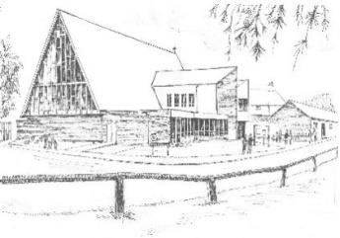**URC Broxbourne**

**Mill Lane EN10 7BQ**

**May CRAFT & PLANT Market**

**Monday 5th May** **1.30pm – 4.30pm**

**Plants Cream Teas**



**Crafts**

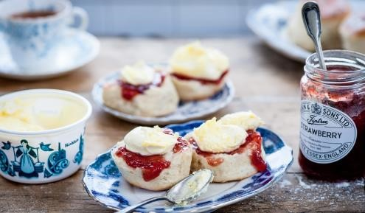

**and much more….. Free Admission**